**Brexit’s generational divide is a major fault line in the E.U. referendum**

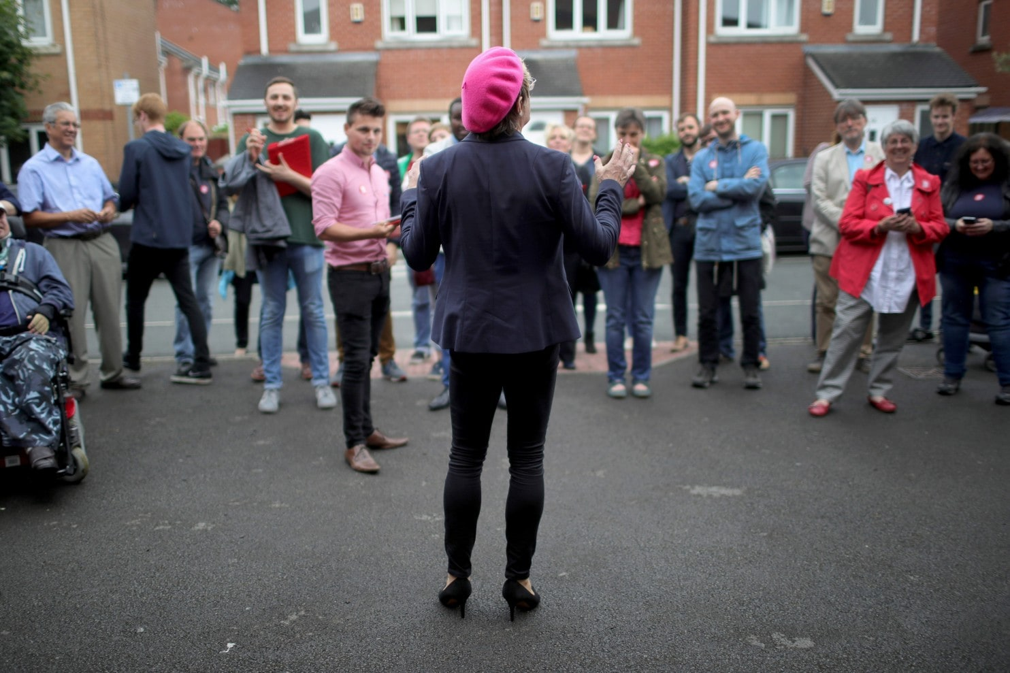

By [**Karla Adam**](https://www.washingtonpost.com/people/karla-adam/)

PORTSMOUTH, England — Eddie Izzard, one of Britain’s most famous comedians, is on a manic, multi-city tour to save the United Kingdom from becoming an isolationist state. But he began a recent debate with charm and bonhomie, encouraging everyone to vote in the European Union referendum Thursday, regardless of their views.

“I’m trying to encourage people to vote ‘remain’ on the 23rd, but if you vote ‘leave,’ fine” said Izzard, speaking this month to a packed lecture at the University of Portsmouth.

Wearing a pink, French-style beret decorated with Union Jack and E.U. badges, he added with a wry smile: “But I would say to the ‘leave’ voters that the voting is on the 24th.”

The generational divide is a major fault line in the E.U. referendum, with the young more pro-E.U. than their elderly counterparts. Campaigning on all sides has been temporarily suspended in the wake of the shooting of British lawmaker Jo Cox on Thursday. But as it resumes, campaigners will seek to energize their bases, with opinion polls showing that the contest is neck and neck.

This is a particular challenge for those rallying young voters, , including Izzard. (When asked by The Washington Post why millennials should listen to a 54-year-old comedian, he laughed: “I don’t know. But I do rather act in a young way. I’m 22 in my head.”)

A recent [YouGov poll](https://d25d2506sfb94s.cloudfront.net/cumulus_uploads/document/0ofltfa592/Times_Results_160606_EU_Final_Website.pdf)found that those between 18 and 24 were the least likely age group to vote, with only 51 percent saying they were absolutely certain they would cast a ballot.

Youth turnout has long been a problem in Britain, and there are fears that it could be exacerbated this year with the referendum date clashing with soccer’s European Championship in France, as well as Glastonbury, a five-day music festival that attracts more than 170,000 people.

“EU ref vote being tactically dated around the same time as Glastonbury and the Euro Cup? This country is being run by snakes,” a graphic design student tweeted.

Political apathy has the potential to hurt the “remain” side the most, with polls showing that younger voters are the most pro-E.U. of any age group.

Percy de Vries, a 20-year-old student campaigning with Students for Europe, said he was pro-E.U. because the bloc offers him the opportunity to work, travel and study in 28 countries. “That resonates quite well with a lot of students,” he said.

Older people are less enthused about the European project. People 65 and older are the most likely to vote to leave the E.U., a position also known as Brexit, which claims that leaving would allow Britain to dramatically curb immigration.

David Banks, organizer for Veterans for Britain, said that older people are more pro-Brexit partly because “they want their independence back,” and partly because they have a longer experience of reading negative headlines about the E.U. from the British press, which is largely Euroskeptic.

For instance, when the E.U. received the Nobel Peace Prize in 2012 for ushering in an era of peace and democracy on a previously war-torn continent, there was bemusement across Europe — but the British press was particularly critical. “EU have got to be joking!” was a headline in the Sun, Britain’s best-selling newspaper.

Older people are also the most motivated to vote. In the YouGov poll, 81 percent of those 65 and older said they were certain to cast a ballot.

The Brexit supporters “tend to hold stronger opinions,” said Will Jennings, a politics professor at the University of Southampton. He added that unlike the Scottish independence referendum in 2014, where a turnout of 85 percent broke records, people were not as engaged with this referendum.

But there are several efforts underway to drive more people to the polls.

Bite the Ballot, a nonpartisan charity that encourages young people to vote, has joined Starbucks, Uber, Tinder and other businesses in an effort to boost turnout. In its partnership with Uber, a screen popped up urging users of the ride-hailing app to register while they waited for their car. Users of the dating app Tinder have been greeted with “fact or fiction” quizzes on Britain’s relationship with the E.U.

Michael Sani, the charity’s founder, said it is more difficult to get young people to vote in Britain than in the United States “because the U.S. fought for the freedom it has today, it almost wrestled for its flag and the Constitution, and you see kids in kindergartens reciting their forefathers. Here we don’t have that, and I think because we never had to fight for it, it’s taken for granted. It’s no one’s fault, but we need a solution.”

Tom Harwood, a 19-year-old who chairs a group called Students for Britain, agreed that it is an uphill battle to get young people interested. “The overwhelming response from students is apathy. One, they don’t feel they know enough, and two, they don’t really care,” he said.

To help strike up conversations on campuses, his supporters are handing out beer nuts and condoms with pro-Brexit slogans such as “Vote Leave: the safer choice.”

For his part, Izzard, a self-described “British European,” said he wanted to make the positive case for Europe.

During his speech at the university, he asked everyone to switch on their smartphones and search for photos of European cities.The students obliged, flicking through pictures of Amsterdam, Copenhagen, Prague.

“This seems to gets lost in the argument . . . all of these amazing places you can go to on low-cost flights,” he said. “We have a beautiful continent. It’s our continent, it is all of ours.”